PEMROGRAMAN JAVA

PERTEMUAN 13

Latihan 1

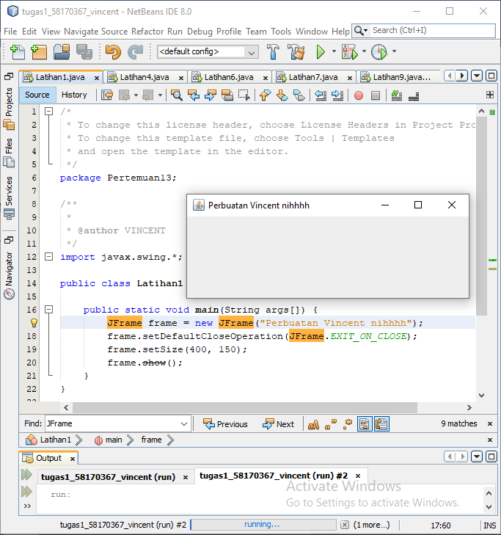

/*

* To change this license header, choose License Headers in Project Properties.

* To change this template file, choose Tools | Templates

* and open the template in the editor.

*/

package Pertemuan13;

/**

*

* @author VINCENT

*/

import javax.swing.*;

public class Latihan1 {

public static void main(String args[]) {

JFrame frame = new JFrame("Perbuatan Vincent nihhhh");

frame.setDefaultCloseOperation(JFrame.EXIT_ON_CLOSE);

frame.setSize(400, 150);

frame.show();

}

}

Latihan 4

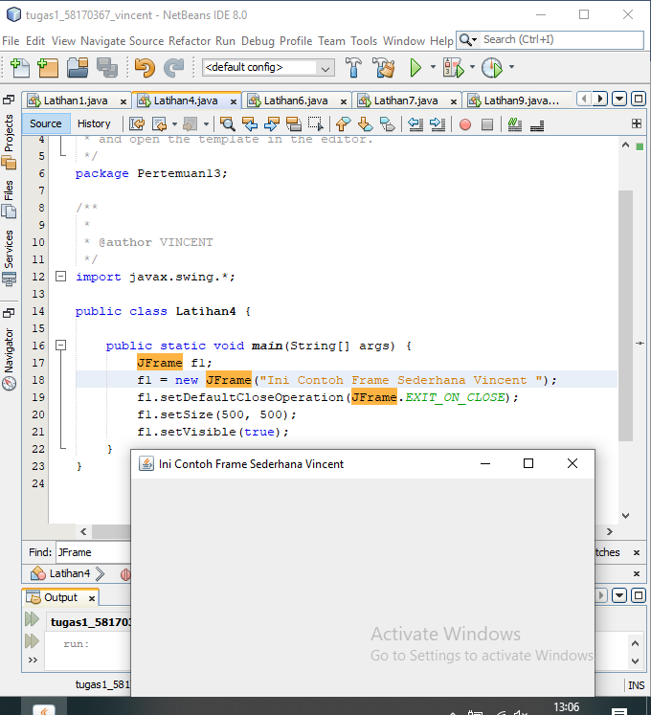

/*

* To change this license header, choose License Headers in Project Properties.

* To change this template file, choose Tools | Templates

* and open the template in the editor.

*/

package Pertemuan13;

/**

*

* @author VINCENT

*/

import javax.swing.*;

public class Latihan4 {

public static void main(String[] args) {

JFrame f1;

f1 = new JFrame("Ini Contoh Frame Sederhana Vincent ");

f1.setDefaultCloseOperation(JFrame.EXIT_ON_CLOSE);

f1.setSize(500, 500);

f1.setVisible(true);

}

}

Latihan 6

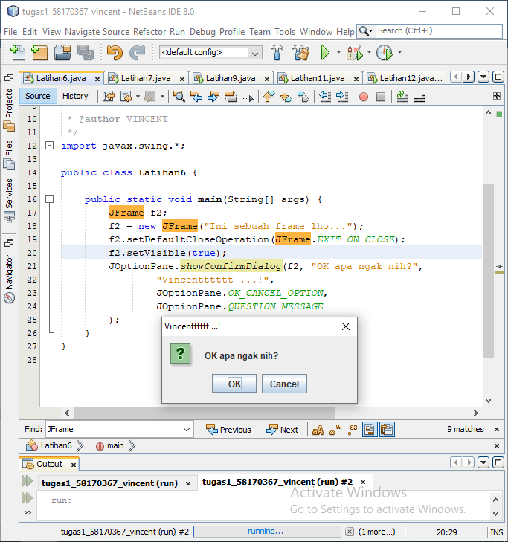

/*

* To change this license header, choose License Headers in Project Properties.

* To change this template file, choose Tools | Templates

* and open the template in the editor.

*/

package Pertemuan13;

/**

*

* @author VINCENT

*/

import javax.swing.*;

public class Latihan6 {

public static void main(String[] args) {

JFrame f2;

f2 = new JFrame("Ini sebuah frame lho...");

f2.setDefaultCloseOperation(JFrame.EXIT_ON_CLOSE);

f2.setVisible(true);

JOptionPane.showConfirmDialog(f2, "OK apa ngak nih?",

"Vincentttttt ...!",

JOptionPane.OK_CANCEL_OPTION,

JOptionPane.QUESTION_MESSAGE

);

}

}

Latihan 7

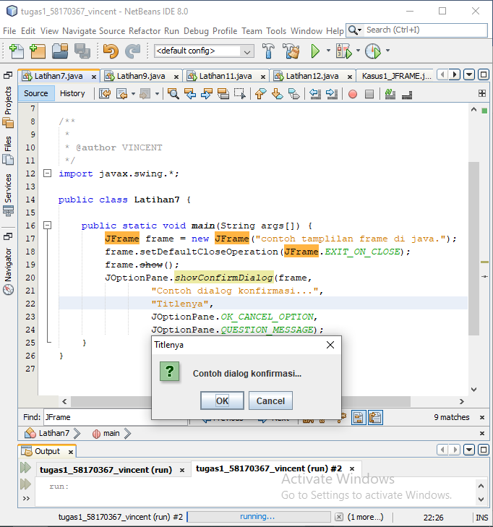

/*

* To change this license header, choose License Headers in Project Properties.

* To change this template file, choose Tools | Templates

* and open the template in the editor.

*/

package Pertemuan13;

/**

*

* @author VINCENT

*/

import javax.swing.*;

public class Latihan7 {

public static void main(String args[]) {

JFrame frame = new JFrame("contoh tamplilan frame di java.");

frame.setDefaultCloseOperation(JFrame.EXIT_ON_CLOSE);

frame.show();

JOptionPane.showConfirmDialog(frame,

"Contoh dialog konfirmasi...",

"Titlenya",

JOptionPane.OK_CANCEL_OPTION,

JOptionPane.QUESTION_MESSAGE);

}

}

Latihan 9

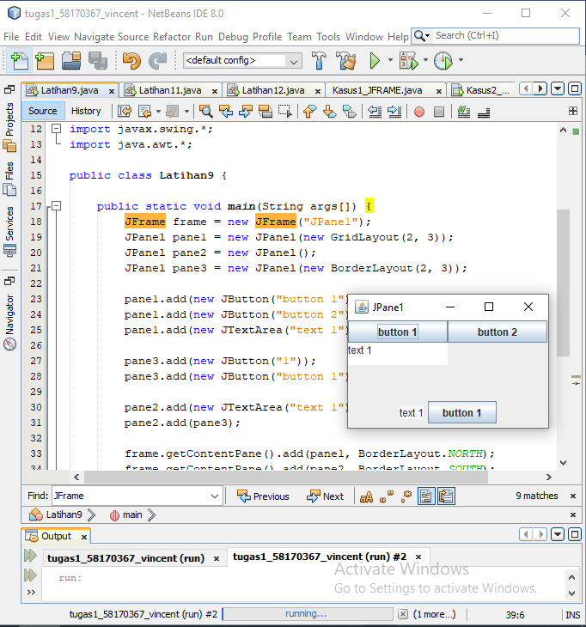

/*

* To change this license header, choose License Headers in Project Properties.

* To change this template file, choose Tools | Templates

* and open the template in the editor.

*/

package Pertemuan13;

/**

*

* @author VINCENT

*/

import javax.swing.*;

import java.awt.*;

public class Latihan9 {

public static void main(String args[]) {

JFrame frame = new JFrame("JPane1");

JPanel pane1 = new JPanel(new GridLayout(2, 3));

JPanel pane2 = new JPanel();

JPanel pane3 = new JPanel(new BorderLayout(2, 3));

pane1.add(new JButton("button 1"));

pane1.add(new JButton("button 2"));

pane1.add(new JTextArea("text 1"));

pane3.add(new JButton("1"));

pane3.add(new JButton("button 1"));

pane2.add(new JTextArea("text 1"));

pane2.add(pane3);

frame.getContentPane().add(pane1, BorderLayout.NORTH);

frame.getContentPane().add(pane2, BorderLayout.SOUTH);

frame.setDefaultCloseOperation(JFrame.EXIT_ON_CLOSE);

frame.pack();

frame.show();

}

}

Latihan 11

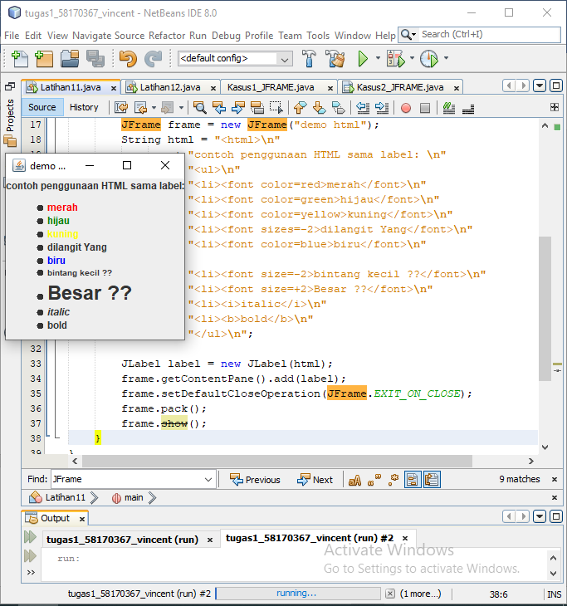

/*

* To change this license header, choose License Headers in Project Properties.

* To change this template file, choose Tools | Templates

* and open the template in the editor.

*/

package Pertemuan13;

/**

*

* @author VINCENT

*/

import javax.swing.*;

public class Latihan11 {

public static void main(String args[]) {

JFrame frame = new JFrame("demo html");

String html = "<html>\n"

+ "contoh penggunaan HTML sama label: \n"

+ "<ul>\n"

+ "<li><font color=red>merah</font>\n"

+ "<li><font color=green>hijau</font>\n"

+ "<li><font color=yellow>kuning</font>\n"

+ "<li><font sizes=-2>dilangit Yang</font>\n"

+ "<li><font color=blue>biru</font>\n"

+ "<li><font size=-2>bintang kecil ??</font>\n"

+ "<li><font size=+2>Besar ??</font>\n"

+ "<li><i>italic</i>\n"

+ "<li><b>bold</b>\n"

+ "</ul>\n";

JLabel label = new JLabel(html);

frame.getContentPane().add(label);

frame.setDefaultCloseOperation(JFrame.EXIT_ON_CLOSE);

frame.pack();

frame.show();

}

}

Latihan 12

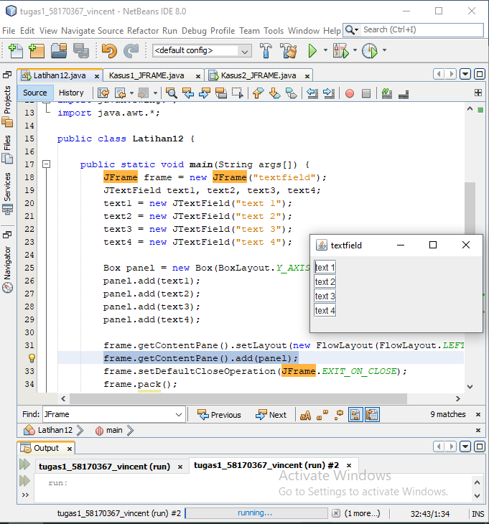

/*

* To change this license header, choose License Headers in Project Properties.

* To change this template file, choose Tools | Templates

* and open the template in the editor.

*/

package Pertemuan13;

/**

*

* @author VINCENT

*/

import javax.swing.*;

import java.awt.*;

public class Latihan12 {

public static void main(String args[]) {

JFrame frame = new JFrame("textfield");

JTextField text1, text2, text3, text4;

text1 = new JTextField("text 1");

text2 = new JTextField("text 2");

text3 = new JTextField("text 3");

text4 = new JTextField("text 4");

Box panel = new Box(BoxLayout.Y_AXIS);

panel.add(text1);

panel.add(text2);

panel.add(text3);

panel.add(text4);

frame.getContentPane().setLayout(new FlowLayout(FlowLayout.LEFT));

frame.getContentPane().add(panel);

frame.setDefaultCloseOperation(JFrame.EXIT_ON_CLOSE);

frame.pack();

frame.show();

}

}

Kasus 1

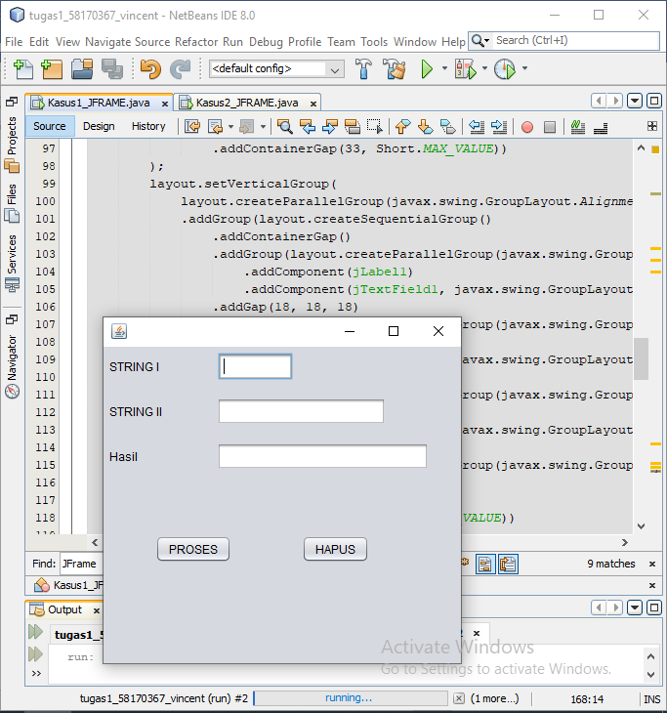

/*

* To change this license header, choose License Headers in Project Properties.

* To change this template file, choose Tools | Templates

* and open the template in the editor.

*/

package Pertemuan13;

/**

*

* @author VINCENT

*/

public class Kasus1_JFRAME extends javax.swing.JFrame {

/**

* Creates new form Kasus1_JFRAME

*/

public Kasus1_JFRAME() {

initComponents();

}

/**

* This method is called from within the constructor to initialize the form.

* WARNING: Do NOT modify this code. The content of this method is always

* regenerated by the Form Editor.

*/

@SuppressWarnings("unchecked")

// <editor-fold defaultstate="collapsed" desc="Generated Code">

private void initComponents() {

jLabel1 = new javax.swing.JLabel();

jLabel2 = new javax.swing.JLabel();

jLabel3 = new javax.swing.JLabel();

jTextField1 = new javax.swing.JTextField();

jTextField2 = new javax.swing.JTextField();

jTextField3 = new javax.swing.JTextField();

jButton1 = new javax.swing.JButton();

jButton2 = new javax.swing.JButton();

setDefaultCloseOperation(javax.swing.WindowConstants.EXIT_ON_CLOSE);

jLabel1.setText("STRING I");

jLabel2.setText("STRING II");

jLabel3.setText("Hasil");

jTextField1.addActionListener(new java.awt.event.ActionListener() {

public void actionPerformed(java.awt.event.ActionEvent evt) {

jTextField1ActionPerformed(evt);

}

});

jTextField2.addActionListener(new java.awt.event.ActionListener() {

public void actionPerformed(java.awt.event.ActionEvent evt) {

jTextField2ActionPerformed(evt);

}

});

jButton1.setText("PROSES");

jButton1.addActionListener(new java.awt.event.ActionListener() {

public void actionPerformed(java.awt.event.ActionEvent evt) {

jButton1ActionPerformed(evt);

}

});

jButton2.setText("HAPUS");

javax.swing.GroupLayout layout = new javax.swing.GroupLayout(getContentPane());

getContentPane().setLayout(layout);

layout.setHorizontalGroup(

layout.createParallelGroup(javax.swing.GroupLayout.Alignment.LEADING)

.addGroup(layout.createSequentialGroup()

.addGroup(layout.createParallelGroup(javax.swing.GroupLayout.Alignment.LEADING)

.addGroup(layout.createSequentialGroup()

.addContainerGap()

.addGroup(layout.createParallelGroup(javax.swing.GroupLayout.Alignment.LEADING)

.addGroup(layout.createSequentialGroup()

.addComponent(jLabel1)

.addGap(60, 60, 60)

.addComponent(jTextField1, javax.swing.GroupLayout.PREFERRED_SIZE, 77, javax.swing.GroupLayout.PREFERRED_SIZE))

.addGroup(layout.createSequentialGroup()

.addGroup(layout.createParallelGroup(javax.swing.GroupLayout.Alignment.LEADING)

.addComponent(jLabel3)

.addComponent(jLabel2))

.addGap(56, 56, 56)

.addGroup(layout.createParallelGroup(javax.swing.GroupLayout.Alignment.LEADING, false)

.addGroup(layout.createSequentialGroup()

.addComponent(jTextField2)

.addGap(44, 44, 44))

.addComponent(jTextField3, javax.swing.GroupLayout.PREFERRED_SIZE, 217, javax.swing.GroupLayout.PREFERRED_SIZE)))))

.addGroup(layout.createSequentialGroup()

.addGap(53, 53, 53)

.addComponent(jButton1)

.addGap(72, 72, 72)

.addComponent(jButton2)))

.addContainerGap(33, Short.MAX_VALUE))

);

layout.setVerticalGroup(

layout.createParallelGroup(javax.swing.GroupLayout.Alignment.LEADING)

.addGroup(layout.createSequentialGroup()

.addContainerGap()

.addGroup(layout.createParallelGroup(javax.swing.GroupLayout.Alignment.BASELINE)

.addComponent(jLabel1)

.addComponent(jTextField1, javax.swing.GroupLayout.PREFERRED_SIZE, javax.swing.GroupLayout.DEFAULT_SIZE, javax.swing.GroupLayout.PREFERRED_SIZE))

.addGap(18, 18, 18)

.addGroup(layout.createParallelGroup(javax.swing.GroupLayout.Alignment.BASELINE)

.addComponent(jLabel2)

.addComponent(jTextField2, javax.swing.GroupLayout.PREFERRED_SIZE, javax.swing.GroupLayout.DEFAULT_SIZE, javax.swing.GroupLayout.PREFERRED_SIZE))

.addGap(18, 18, 18)

.addGroup(layout.createParallelGroup(javax.swing.GroupLayout.Alignment.BASELINE)

.addComponent(jLabel3)

.addComponent(jTextField3, javax.swing.GroupLayout.PREFERRED_SIZE, javax.swing.GroupLayout.DEFAULT_SIZE, javax.swing.GroupLayout.PREFERRED_SIZE))

.addGap(67, 67, 67)

.addGroup(layout.createParallelGroup(javax.swing.GroupLayout.Alignment.BASELINE)

.addComponent(jButton1)

.addComponent(jButton2))

.addContainerGap(103, Short.MAX_VALUE))

);

pack();

}// </editor-fold>

private void jButton1ActionPerformed(java.awt.event.ActionEvent evt) {

// TODO add your handling code here:

}

private void jTextField1ActionPerformed(java.awt.event.ActionEvent evt) {

// TODO add your handling code here:

}

private void jTextField2ActionPerformed(java.awt.event.ActionEvent evt) {

// TODO add your handling code here:

}

/**

* @param args the command line arguments

*/

public static void main(String args[]) {

/* Set the Nimbus look and feel */

//<editor-fold defaultstate="collapsed" desc=" Look and feel setting code (optional) ">

/* If Nimbus (introduced in Java SE 6) is not available, stay with the default look and feel.

* For details see http://download.oracle.com/javase/tutorial/uiswing/lookandfeel/plaf.html

*/

try {

for (javax.swing.UIManager.LookAndFeelInfo info : javax.swing.UIManager.getInstalledLookAndFeels()) {

if ("Nimbus".equals(info.getName())) {

javax.swing.UIManager.setLookAndFeel(info.getClassName());

break;

}

}

} catch (ClassNotFoundException ex) {

java.util.logging.Logger.getLogger(Kasus1_JFRAME.class.getName()).log(java.util.logging.Level.SEVERE, null, ex);

} catch (InstantiationException ex) {

java.util.logging.Logger.getLogger(Kasus1_JFRAME.class.getName()).log(java.util.logging.Level.SEVERE, null, ex);

} catch (IllegalAccessException ex) {

java.util.logging.Logger.getLogger(Kasus1_JFRAME.class.getName()).log(java.util.logging.Level.SEVERE, null, ex);

} catch (javax.swing.UnsupportedLookAndFeelException ex) {

java.util.logging.Logger.getLogger(Kasus1_JFRAME.class.getName()).log(java.util.logging.Level.SEVERE, null, ex);

}

//</editor-fold>

/* Create and display the form */

java.awt.EventQueue.invokeLater(new Runnable() {

public void run() {

new Kasus1_JFRAME().setTitle("GUI Vincent");

new Kasus1_JFRAME().setVisible(true);

}

});

}

// Variables declaration - do not modify

private javax.swing.JButton jButton1;

private javax.swing.JButton jButton2;

private javax.swing.JLabel jLabel1;

private javax.swing.JLabel jLabel2;

private javax.swing.JLabel jLabel3;

private javax.swing.JTextField jTextField1;

private javax.swing.JTextField jTextField2;

private javax.swing.JTextField jTextField3;

// End of variables declaration

}

Kasus 2

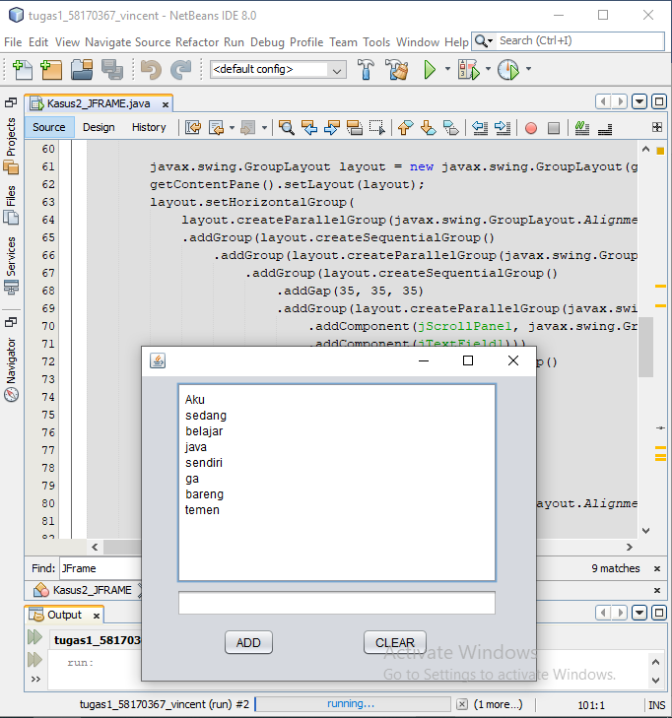

/*

* To change this license header, choose License Headers in Project Properties.

* To change this template file, choose Tools | Templates

* and open the template in the editor.

*/

package Pertemuan13;

/**

*

* @author VINCENT

*/

public class Kasus2_JFRAME extends javax.swing.JFrame {

/**

* Creates new form Kasus2_JFRAME

*/

public Kasus2_JFRAME() {

initComponents();

}

/**

* This method is called from within the constructor to initialize the form.

* WARNING: Do NOT modify this code. The content of this method is always

* regenerated by the Form Editor.

*/

@SuppressWarnings("unchecked")

// <editor-fold defaultstate="collapsed" desc="Generated Code">

private void initComponents() {

jScrollPane1 = new javax.swing.JScrollPane();

jTextArea1 = new javax.swing.JTextArea();

jTextField1 = new javax.swing.JTextField();

jButton1 = new javax.swing.JButton();

jButton2 = new javax.swing.JButton();

setDefaultCloseOperation(javax.swing.WindowConstants.EXIT_ON_CLOSE);

jTextArea1.setEditable(false);

jTextArea1.setColumns(20);

jTextArea1.setLineWrap(true);

jTextArea1.setRows(5);

jTextArea1.setText("Aku \nsedang\nbelajar \njava\nsendiri \nga \nbareng \ntemen");

jTextArea1.setWrapStyleWord(true);

jScrollPane1.setViewportView(jTextArea1);

jButton1.setText("ADD");

jButton1.addActionListener(new java.awt.event.ActionListener() {

public void actionPerformed(java.awt.event.ActionEvent evt) {

jButton1ActionPerformed(evt);

}

});

jButton2.setText("CLEAR");

jButton2.addActionListener(new java.awt.event.ActionListener() {

public void actionPerformed(java.awt.event.ActionEvent evt) {

jButton2ActionPerformed(evt);

}

});

javax.swing.GroupLayout layout = new javax.swing.GroupLayout(getContentPane());

getContentPane().setLayout(layout);

layout.setHorizontalGroup(

layout.createParallelGroup(javax.swing.GroupLayout.Alignment.LEADING)

.addGroup(layout.createSequentialGroup()

.addGroup(layout.createParallelGroup(javax.swing.GroupLayout.Alignment.LEADING)

.addGroup(layout.createSequentialGroup()

.addGap(35, 35, 35)

.addGroup(layout.createParallelGroup(javax.swing.GroupLayout.Alignment.LEADING, false)

.addComponent(jScrollPane1, javax.swing.GroupLayout.DEFAULT_SIZE, 326, Short.MAX_VALUE)

.addComponent(jTextField1)))

.addGroup(layout.createSequentialGroup()

.addGap(82, 82, 82)

.addComponent(jButton1)

.addGap(88, 88, 88)

.addComponent(jButton2)))

.addContainerGap(39, Short.MAX_VALUE))

);

layout.setVerticalGroup(

layout.createParallelGroup(javax.swing.GroupLayout.Alignment.LEADING)

.addGroup(layout.createSequentialGroup()

.addContainerGap()

.addComponent(jScrollPane1, javax.swing.GroupLayout.PREFERRED_SIZE, 204, javax.swing.GroupLayout.PREFERRED_SIZE)

.addPreferredGap(javax.swing.LayoutStyle.ComponentPlacement.RELATED)

.addComponent(jTextField1, javax.swing.GroupLayout.PREFERRED_SIZE, javax.swing.GroupLayout.DEFAULT_SIZE, javax.swing.GroupLayout.PREFERRED_SIZE)

.addPreferredGap(javax.swing.LayoutStyle.ComponentPlacement.UNRELATED)

.addGroup(layout.createParallelGroup(javax.swing.GroupLayout.Alignment.BASELINE)

.addComponent(jButton1)

.addComponent(jButton2))

.addContainerGap(25, Short.MAX_VALUE))

);

pack();

}// </editor-fold>

private void jButton1ActionPerformed(java.awt.event.ActionEvent evt) {

// TODO add your handling code here:

}

private void jButton2ActionPerformed(java.awt.event.ActionEvent evt) {

// TODO add your handling code here:

}

/**

* @param args the command line arguments

*/

public static void main(String args[]) {

/* Set the Nimbus look and feel */

//<editor-fold defaultstate="collapsed" desc=" Look and feel setting code (optional) ">

/* If Nimbus (introduced in Java SE 6) is not available, stay with the default look and feel.

* For details see http://download.oracle.com/javase/tutorial/uiswing/lookandfeel/plaf.html

*/

try {

for (javax.swing.UIManager.LookAndFeelInfo info : javax.swing.UIManager.getInstalledLookAndFeels()) {

if ("Nimbus".equals(info.getName())) {

javax.swing.UIManager.setLookAndFeel(info.getClassName());

break;

}

}

} catch (ClassNotFoundException ex) {

java.util.logging.Logger.getLogger(Kasus2_JFRAME.class.getName()).log(java.util.logging.Level.SEVERE, null, ex);

} catch (InstantiationException ex) {

java.util.logging.Logger.getLogger(Kasus2_JFRAME.class.getName()).log(java.util.logging.Level.SEVERE, null, ex);

} catch (IllegalAccessException ex) {

java.util.logging.Logger.getLogger(Kasus2_JFRAME.class.getName()).log(java.util.logging.Level.SEVERE, null, ex);

} catch (javax.swing.UnsupportedLookAndFeelException ex) {

java.util.logging.Logger.getLogger(Kasus2_JFRAME.class.getName()).log(java.util.logging.Level.SEVERE, null, ex);

}

//</editor-fold>

/* Create and display the form */

java.awt.EventQueue.invokeLater(new Runnable() {

public void run() {

new Kasus2_JFRAME().setVisible(true);

}

});

}

// Variables declaration - do not modify

private javax.swing.JButton jButton1;

private javax.swing.JButton jButton2;

private javax.swing.JScrollPane jScrollPane1;

private javax.swing.JTextArea jTextArea1;

private javax.swing.JTextField jTextField1;

// End of variables declaration

}